**Netflix Survey Data Analysis Dashboard-Supporting Document**

**Overview**

The **Netflix Survey Data Analysis Dashboard**, created in Power BI, provides comprehensive insights into Netflix's extensive library of shows. By analyzing key factors like show type, rating, release year, and country of production, this dashboard enables users to explore Netflix's content efficiently. This document outlines the data cleaning process, key measures created, and visualizations used for this project.

**Data Cleaning and Transformation Process**

The following steps were applied to the Netflix dataset during the data cleaning and transformation phase to ensure the accuracy and reliability of the analysis:

1. **Added Additional Column**:
   * Created the column "Murder Mystery?" to categorize shows based on whether they belong to the murder mystery genre.
2. **Replace Values**:
   * Standardized categorical and rating text data for consistency across the dataset (e.g., unified variations of rating labels).
3. **Removed Unwanted Columns**:
   * Removed irrelevant columns like 'description' and metadata that did not contribute meaningfully to the analysis.
4. **Split Columns with Delimiter**:
   * Split the ‘duration’ column to extract useful information and created the 'duration in minutes' column for more precise analysis.
5. **Tackled Blank and Duplicated Rows**:
   * Removed rows with missing key values (such as title or release year) and eliminated duplicate entries to ensure data quality.
6. **Additional Column Transformation**:
   * Added additional necessary columns to allow for better data filtering and segmentation in the dashboard.

These steps were crucial for transforming raw data into a structured dataset ready for meaningful analysis.

**Columns Used in Analysis**

The dataset for this project contained the following key columns, essential for understanding Netflix shows:

* **Show Details**:
  + **Listed In**: Genre or category of the show.
  + **Show ID**: Unique identifier for each show.
  + **Cast**: Cast members involved in the show.
  + **Country**: Country of origin for the show.
  + **Director**: Director of the show.
  + **Title**: Name of the show.
* **Categorization & Metrics**:
  + **Duration**: Duration of the show (converted into minutes for precise analysis).
  + **First Category**: Primary genre of the show.
  + **Rating**: Parental rating of the show (e.g., PG, TV-MA, R).
  + **Release Year**: The year the show was released.
  + **Type**: Whether the show is a **Movie** or a **TV Show**.

**Measures Created**

To enhance the analysis, the following custom measures were created:

* **Total Shows**:
  + A measure to calculate the total number of shows listed, segmented by type, genre, and country.
* **Date Added**:
  + A calculated measure to track when the show was added to the Netflix platform, used for time-based visualizations.

These measures allow for more focused insights into the Netflix library's show distribution.

**Visualizations**

The dashboard uses interactive and easy-to-read visualizations to showcase key metrics. Below are the primary visualizations featured in the dashboard:

1. **Show Count by Type**:
   * A pie chart displaying the proportion of **Movies** versus **TV Shows** on the platform.
2. **Show Count by Rating**:
   * A bar chart illustrating the number of shows in each rating category (e.g., **TV-MA**, **PG**, **R**).
3. **Show Count by Release Year**:
   * A bar chart showing the number of shows released each year, giving an overview of Netflix's yearly content production.
4. **Show Count by Country**:
   * A vertical bar graph displaying the distribution of shows by their country of origin.

Below is a screenshot preview of the dashboard:

**Key Insights**

From the data and visualizations, the following insights were extracted:

* **Total Number of Shows**: 10,000+
* **Majority Content Type**: Movies account for 60% of the total shows.
* **Most Popular Rating**: **TV-MA** (Mature Audience) makes up 40% of the shows.
* **Top Country of Production**: The USA leads in content production, contributing to 45% of the entire Netflix library.
* **Yearly Trends**: 2020 saw the highest number of releases, with 300+ new shows added to the platform.

These insights help users understand Netflix's content trends and the distribution of shows based on various factors.

**How to Use the Dashboard**

* **Filter by Type**: Users can filter by show type (Movie or TV Show) to explore content distribution.
* **Drill Down by Country**: Use the country filters to view the production details by region.
* **Analyze Show Ratings**: The rating filter allows users to focus on specific content suitable for different audience groups.

This interactive dashboard is designed to make content exploration easier and provides users with comprehensive data for deep analysis.

**License**

This project is licensed under the **MIT License**. You are free to use, modify, and distribute this work with proper attribution. Please see the LICENSE file for more details.

**Screenshot**

Below is a preview of the **Netflix Survey Data Analysis Dashboard**, highlighting key show metrics and visualizations:

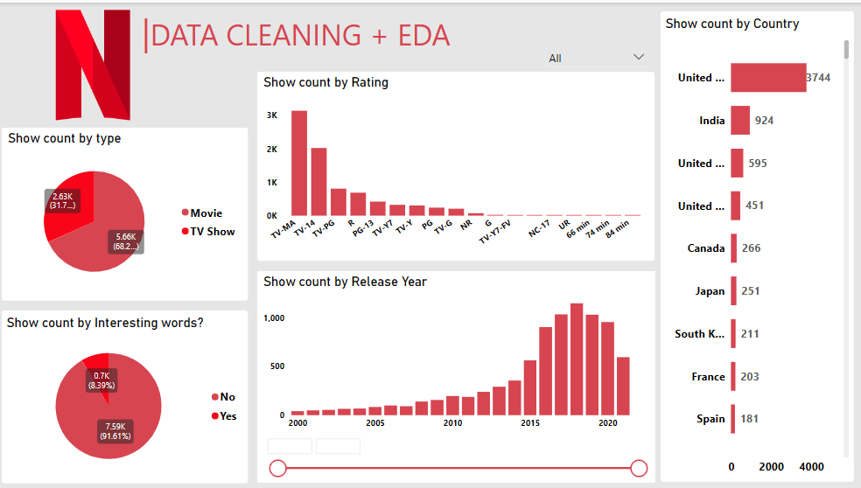

**Installation**

To use this **Netflix Survey Data Analysis Dashboard**:

1. Download the .pbix file.
2. Open it in **Power BI Desktop**.
3. Replace the data source with your own Netflix data or any similar dataset.
4. Adjust and modify the measures, columns, and visualizations to suit your specific requirements.

**Contributing**

Contributions are welcome! To contribute to this project:

* Create issues for bugs or improvements.
* Suggest new features or enhancements.
* Submit pull requests with code improvements or additions.

For contribution guidelines, please refer to the **CONTRIBUTING.md** file in the repository.

**Conclusion**

The **Netflix Survey Data Analysis Dashboard** leverages effective data cleaning and transformation techniques to provide detailed insights into Netflix’s show library. Through powerful visualizations, users can explore and analyze key content metrics such as show type, rating, release year, and country of production, leading to a better understanding of Netflix's vast content offerings.